Name: ______________________________________________________Date: __________________________

|  |  |  |  |  |
| --- | --- | --- | --- | --- |
| **Set Notation** | **Pronunciation** | **Meaning** | **Venn Diagram** | **Answer** |
|  | “A union B” | Everything in  both sets; to unite; Used in OR problems | A union B is shaded  **A**  **B**  **A**  **B**  **A**  **B**  **A**  **B**  **A**  **B** |  |
|  | “A intersect B” | Only what is in common with  both sets; Used in AND problems | A intersect B is shaded |  |
|  | “A complement” | Everything NOT  in set A | the complement of A is shaded |  |
|  | “not A union B” | Everything NOT in  set A and set B | the complement of A union B is shaded |  |
|  | “ not A intersect B” | Everything NOT in common between set A and set B | the complement of A intersect B is shaded |  |

Honors Geometry Intro to Venn Diagrams NOTES

(wkst 11.6)

States that you would consider living in:

{GA, FL, NC, SC, IL, WA, OR, MT, ME, AZ, MO}

You are very interested in these three characteristics:

A: being close to an ocean {GA, FL, NC, SC, WA, OR, ME}

B: having a pro baseball team: {GA, FL, WA, MO, IL, AZ}

C: likely to have a White Christmas: {IL, MT, ME, MO}

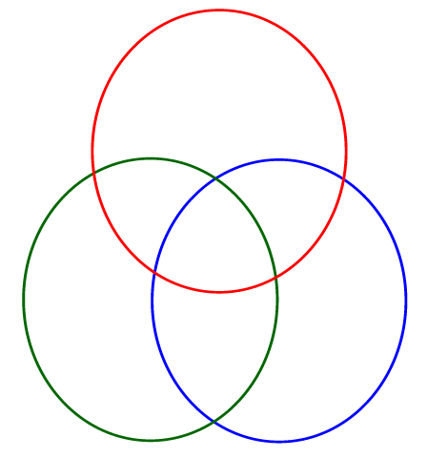

FIND THE FOLLOWING PROBABILITIES

a)  b) 

c) B’ d) 

e)  f) 

g)  h) 