Name: __________________________________________ Date: _____________________________

Identify the Five-Number Summary number for the data of Johnny’s test scores and draw the Box & Whisker plot.
92, 96, 97, 83, 92, 58, 93, 88, 77, 48, 65, 80, 71

Mean = 80
48
97
92.5
83
68
Min = 48, Q1= 68, Median = 83, Q3 = 92.5, Max = 97
What is the range?49 IQR? 24.5 MAD? 12.46
Are there any outliers in the data set?
No 68 – 1.5(24.5) = 31.25 92.5 + 1.5(24.5) = 129.25

- The table gives the low temperatures in Chicago on eight randomly selected winter days. Which measure of central tendency probably gives the LEAST ACCURATE prediction of a "typical" low temperature on a Chicago winter day?
Chicago Lows
17 | 25 | 28 | 12 | 16 | 55 | 18 | 22

Mean = 24.125, Median = 20 The Mean is greatly affected by 55, which is an outlier.

- Describe the shape of the distribution. Estimate the mean, median and upper and lower quartiles for the data.
Skewed right
Mean ≈ between 20 - 25
Median = 20-25 for Person 9
Q1 = 15-20 between Person 4 and 5
Q3 = 30-35 between Person 13 and 14
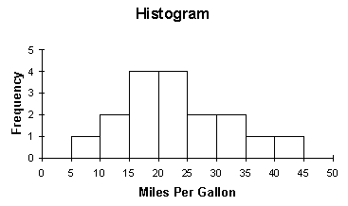

- Construct a frequency table from the following information:
A survey of 200 9th and 10th graders was given to determine what their favorite subject was. 72 said Math (50 which were freshmen), 38 said Social Studies (20 which were sophomores), and 40 freshmen and 50 sophomores said PE was their favorite.

 | Math | SS | PE | Total
9th | 50 | 18 | 40 | 108
10th | 22 | 20 | 50 | 92
Total | 72 | 38 | 90 | 200
Based on your table above, answer the following questions:
- What are the marginal relative frequencies? _36%, 19%, 45%, 54%, 46%
- What are the joint relative frequencies?25%, 9%, 20%(top), 11%, 10%, 25%(bottom)
- What is the probability that a student surveyed is a freshman? 54%
- What is the probability that a student surveyed likes Math? 36%
- If a student likes Math, what is the probability that they are a freshman?69.4%

