Geometry Name:______________________________________

Triangles Test Review - PART A Date:_____________________ Period:_________

1. Find the value of the variable, answer the questions & then classify the triangle.

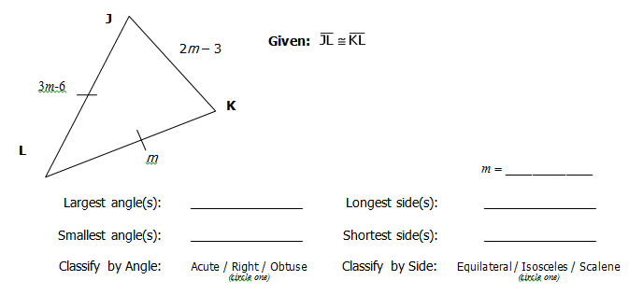

Can you find the longest side? Can you find the smallest angle? Explain!

1. For each pair of triangles tell the following:
   1. Are they congruent? If they are congruent then
   2. Write the triangle congruency statement
   3. Give the postulate that makes them congruent

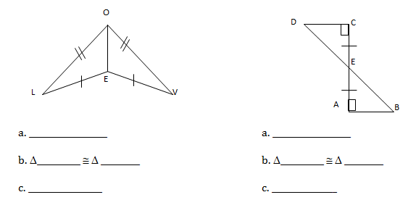

LOE

DCE

1. Use the diagram below to find each angle measure.

1. _______ 2. ______

3. _______ 4. ______

5. _______ 6. ______

7. _______ 8. ______

9. _______ 10. ______



1. Write a **2-column** proof with the following information.

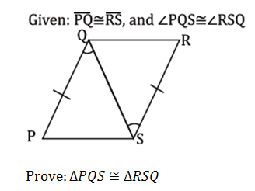

**∆_________**

Statements Reasons

1. Write a **2-column** proof with the following information.

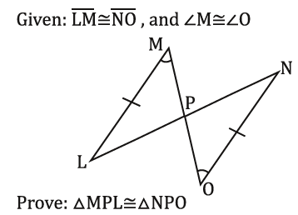

**∆_________**

Statements Reasons

1. Write a proof with the following information ☺

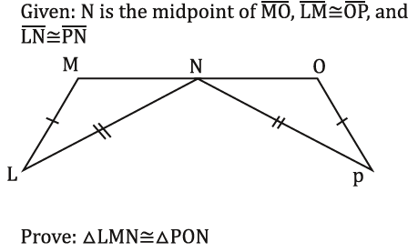

Statements Reasons

**∆_________**

1. What best describes the triangle below?

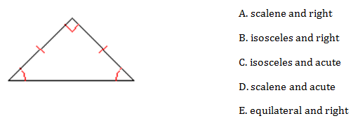

1. List the five theorems we can use to prove triangles congruent. (theorems…sss, etc.)
2. List the two ways we CANNOT use to prove triangles are congruent.

**\*\*\*REMEMBER…this is NOT your only study guide! Please study your quiz, notes, and homework!\*\*\***