**Algebra 1 Name _____________________________**

**Review for Test – UNIT 2 PART B Date ________ Period ___**

**I. Arithmetic Sequences**

**Find the next three terms of the arithmetic sequence.**

1.  2. 

|  |  |  |  |  |
| --- | --- | --- | --- | --- |
| Term Number (n) | **1** | **2** | **3** | **4** |
| Value (an) | **17** | **23** | **29** | **35** |

3. Use the table to write an explicit formula

for the sequence. _____________________

|  |  |  |  |  |  |  |
| --- | --- | --- | --- | --- | --- | --- |
| Term Number (n) | **1** | **2** | **3** | **4** | **5** | **6** |
| Value (an) |  |  |  |  |  |  |

4.

Given the following information,

fill in the table.

a1 = 6; d = -4

5. Given the following explicit formula, find the next terms.

an = 4 – 9(n – 1) a2 = _____ a6 = _____ a9 = _____

|  |  |  |  |  |  |  |
| --- | --- | --- | --- | --- | --- | --- |
| Term Number (n) | **1** | **2** | **3** | **4** | **5** | **6** |
| Value (an) |  |  |  |  |  |  |

6.

Given the following explicit formula,

fill in the table.

an = 11 + 3(n – 1)

**Fill in the blanks and write the explicit formula.**

7. 16, 3, -10, … a1 = _____ d = _____ ______________

8. 6, 15, 24, … a1 = _____ d = _____ ______________

**Write the explicit formula and find the terms.**

9. 8, 11, 14, … ______________ a34 = ______ a105 = ______

10. -1, -8, -15, … ______________ a100 = ______ a157 = ______

11. Kerpippy has $15 in her piggy bank. She decides to add $2 each week.

a) Write the first four terms of the arithmetic sequence. (Hint: Term 1 is after week 1.)

b) Write the explicit formula for the arithmetic sequence.

c) Her goal is to buy Barbie a tank for $49 in 20 weeks. Will she have enough money by then?

**Given the following info**, **find the first term.**

12. a12 = –10; d = 4 a1 = _______________

**Find the next three terms. Name the term a1. State whether the sequence is arithmetic or not. If it is arithmetic, find the common difference.**

13. 1, 4, 7, 10, _______, _______, _______ a1 = ______ arithmetic? _______ d = ______

14. 3, 6, 12, 24, _______, _______, _______ a1 = ______ arithmetic? _______ d = ______

15. Given the arithmetic sequence, write a simplified explicit formula. Then, use your formula to find the terms.

18, 25, 32, 39, … an = _______________ a10 = ________ a25 = ________

**II. Systems of Equations**

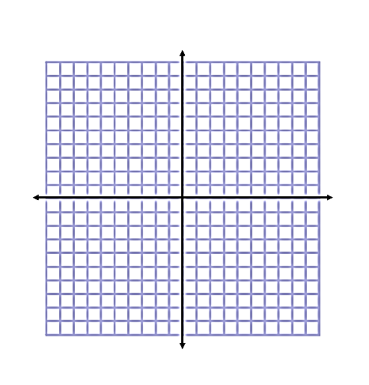**Solve the system of equations by graphing and state the solution.**

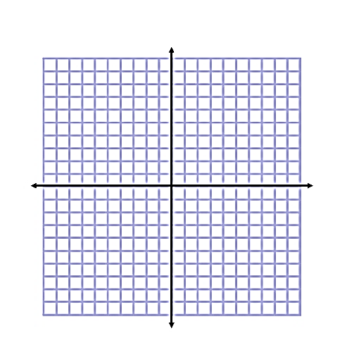

1.  2.

 

_____________ _____________



3.  4. 

 

_____________ _____________

**Solve each system of equations algebraically (use elimination).**

5.  6.  7. 

8.  9.  10. 

**Write a system that could be used to solve each problem. Then, solve the system and answer the question.**

11. Caroline and Rachel are selling flower bulbs for a school fundraiser. Customers can buy bags of windflower bulbs and bags of daffodil bulbs. Caroline sold 6 bags of windflower bulbs and 12 bags of daffodil bulbs for a total of $324. Rachel sold 6 bags of windflower bulbs and 8 bags of daffodil bulbs for a total of $244. What is the cost each of one bag of windflower bulbs and one bag of daffodil bulbs?

12. A sold-out movie theater will seat 60 people. At a premiere, tickets were $8 for adults and $5 for children. If the theater made $420 on premiere night, how many children bought a ticket?

14.Without graphing the equations, is the point (2, -1) the solution to the system  ?

15. Without graphing the inequalities, is the point (-1, 4) a solution to the system ?

**III. Inequalities & Systems of Inequalities**

Graph the inequality.

1. x > 4 2. x  -2

**Solve the inequality.  Write the answer in inequality and interval notations and graph the solution.**

5. 2 > x + 7 6. 2(3 – x) + 8 10



7. Which of the following is a solution to 7 < -2(x + 4) – 3x?

A. -10 B. -3 C. 3 D. 10

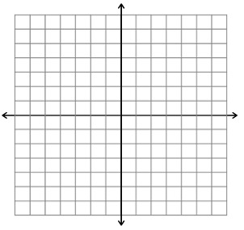8. Graph each inequality and determine if the given points are solutions.

1.  b. 

Is (0, -1) a solution? ___________ Is (2, 1) a solution? ___________

Is (-6, -2) a solution? ___________ Is (-4, 0) a solution? __________

**Graph the solution to the system of inequalities and name a possible solution.**



9.  10. 

_____________ _____________

11.  12. 

_____________ _____________

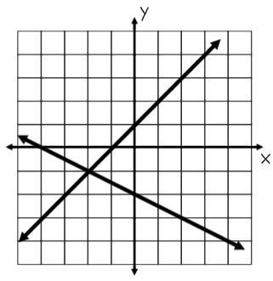

_______ 13. Which system of equations is graphed on the right?

A.  B. 

C.  D. 

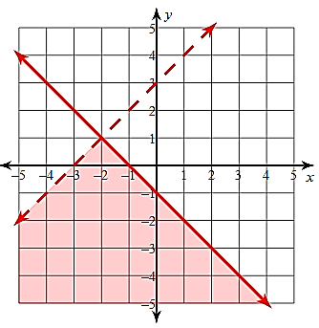

14. Use the graph to the right to answer the following questions.

A. Name 3 possible solutions to the system of inequalities.

B. Name 3 points that are NOT solutions to the system.

C. Write the two inequalities that are graphed in   
slope-intercept form.

y _______________________

y _______________________

15. Jordyn has at least $80 in her wallet that consists of $5 and $10 bills. She has at most 14 bills in her wallet. Write a system of inequalities that could be used to describe the scenario. Then graph on the coordinate plane.

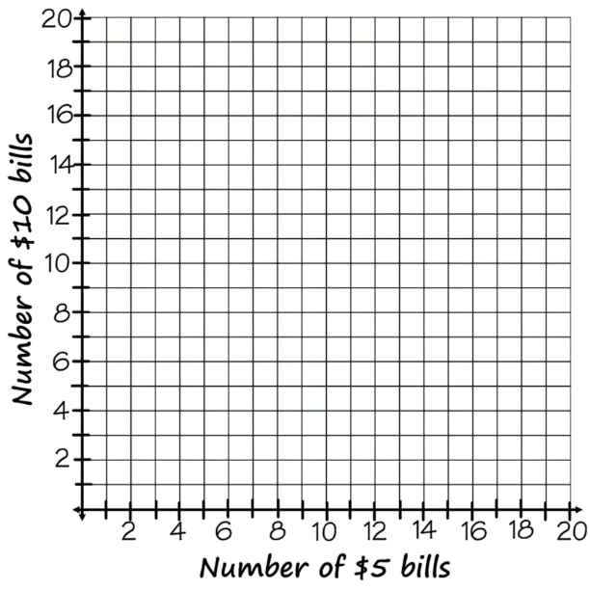

x represents ____________________________

y represents ____________________________

Equation 1: _______________________________

Equation 2: _______________________________

Equations in slope-int form (y=mx+b): ________________________________

________________________________

Name one possible solution: (____, ____)

Write what this solution means in context:

_______ 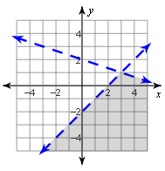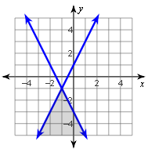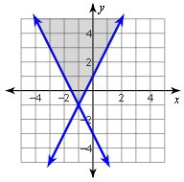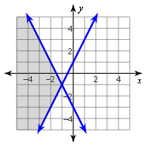16. Which of these shows the correct graph of this system of inequalities? 

A. B. C. D.