Algebra 1 – Test Review Name: _____________________________________

Graphing Quadratic Equations & Characteristics & Transformations

**Describe the transformation using the quadratic equation.**

1.  2. 

Horizontal Shift: ______________ Horizontal Shift:________________

Reflection: none x-axis y-axis Reflection: none x-axis y-axis

Vertical Shift: ________________ Vertical Shift: ________________

Dilation: none stretch shrink Dilation: none stretch shrink

3.  4. 

Horizontal Shift: ______________ Horizontal Shift:________________

Reflection: none x-axis y-axis Reflection: none x-axis y-axis

Vertical Shift: ________________ Vertical Shift: ________________

Dilation: none stretch shrink Dilation: none stretch shrink

**Identify the vertex of each graph; identify whether it is a minimum or a maximum.**

5. 6.

Vertex: ( , ) _________ Vertex: ( , ) _________

**Without graphing the quadratic functions, complete the requested information:**

|  |  |
| --- | --- |
| 7.  What is the direction of opening? _______  Is the vertex a max or min? _______  Wider or narrower than *y* = *x*2 ? __________ | 8.  What is the direction of opening? _______  Is the vertex a max or min? _______  Wider or narrower than *y* = *x*2 ? ___________ |

**Graph the following equation and find the requested information.**

9. f(x)= -x2 + 2x + 3Opens: UP or DOWN10. f(x)= 2x2 – 8x + 6Opens: UP or DOWN

Form: _________________________________ Form: _________________________________

AOS: ____________ Vertex: ____________ AOS: ____________ Vertex: ____________

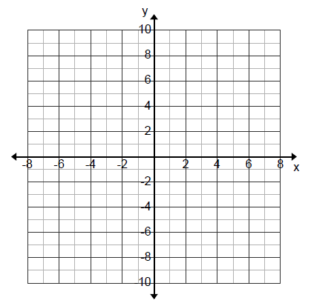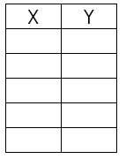y-intercept: ____________ y-intercept: ____________



11. f(x)= 0.5(x – 2)(x + 4)Opens: UP or DOWN12. f(x)= -x(x +2)Opens: UP or DOWN

Form: _________________________________ Form: _________________________________

x-intercepts: ___________________________ x-intercepts: ___________________________

AOS: ____________ Vertex: ____________ AOS: ____________ Vertex: ____________

y-intercept: ____________ y-intercept: ____________



13. f(x)= 3(x – 1)2 – 10 Opens: UP or DOWN14. f(x)= -x2 – 2 Opens: UP or DOWN

Form: _________________________________ Form: _________________________________

AOS: ____________ Vertex: ____________ AOS: ____________ Vertex: ____________

y-intercept: ____________ y-intercept: ____________



|  |  |
| --- | --- |
| Vertex |  |
| Domain |  |
| Range |  |
| Increasing Interval |  |
| Decreasing Interval |  |
| Zeros |  |
| Y-intercept |  |
| Maximum |  |
| Minimum |  |
| Axis of Symmetry |  |
| Left End Behavior | As x🡪-, y🡪 _______ |
| Right End Behavior | As x🡪, y🡪 _______ |

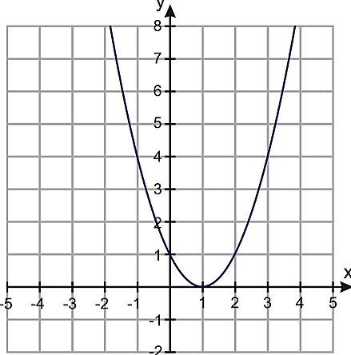15.

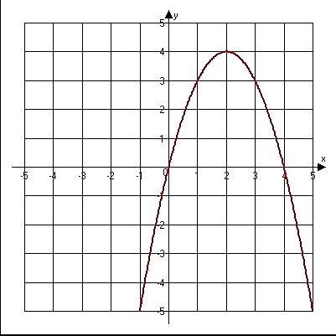

|  |  |
| --- | --- |
| Vertex |  |
| Domain |  |
| Range |  |
| Increasing Interval |  |
| Decreasing Interval |  |
| Zeros |  |
| Y-intercept |  |
| Maximum |  |
| Minimum |  |
| Axis of Symmetry |  |
| Left End Behavior | As x🡪-, y🡪 _______ |
| Right End Behavior | As x🡪, y🡪 _______ |

16.

_______ 17. What is the vertex of the following quadratic function ?

A. (-3, -2) B. (-2, 4) C. (2, 4) D. (-3, 4)

_______ 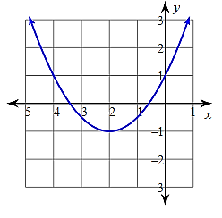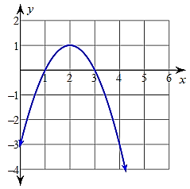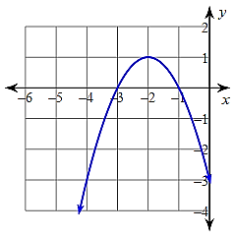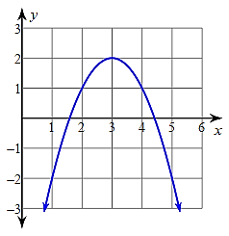18. Which of the following graphs has an increasing interval from (-, -2)?

A. B. C. D.

_______ 19. What transformation occurs in this function ?

A. down 7 units B. up 7 units C. right 7 units D. left 7 units