Geometry Name: _________________________________
Test Review – Unit 12 Date: _____________________
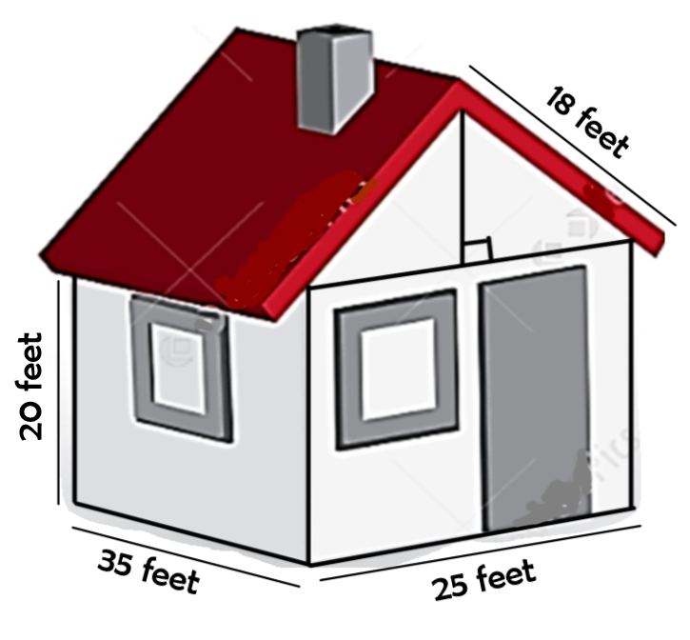
Use the following house diagram to answer the questions. Assume that the house only has the one door and two windows that are visible.
*The doors dimensions are 3 feet x 9 feet.
*Both of the window dimensions are 3 feet x 3 feet.
1. What is the total area of both of the windows?

2. What is the area of the door?

3. What is the area of the walls (all 4 sides)
EXCLUDING the windows and door?

4. You want to paint the house yellow. The paint you like is $4.15 per square foot. How much will you need to spend on paint?

5. What is the area of the roof [ignore the chimney]? If shingles cost $17.25 a square foot, how much will you spend to reshingle the house?

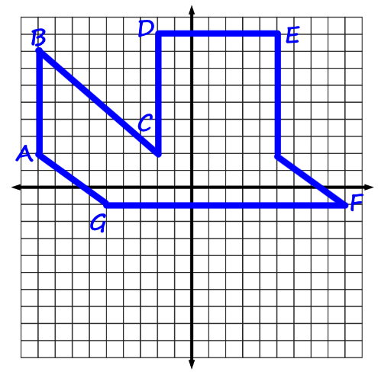
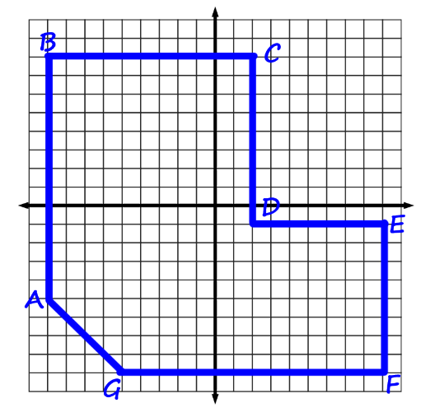
Find the perimeter and area of the following shapes.
6. 7.

Perimeter: ___________ Area: ___________ Perimeter: ___________ Area: ___________
Formula for partitioning segments: ________________________________________
8. Find the point T so that the directed line segment from A(1,2) to B(3,9) is partitioned into a ratio of 2:3.

9. Find the point T so that the directed line segment from A(-2, 5) to B(4,-1) is partitioned into a ratio of 1:4.

10. The point T is located three-fourths the distance from A(0, 4) to B(-1,-1). Find the point T.

11. Find the coordinates of T that partition A(-9,5) to B(3,-1) into a 4:5 ratio.

12. Find the coordinates of T that partition A(9, -10) to B (1,0) into a 5:2 ratio.

13. A great steakhouse is ⁴/₅ of the way from Kaleb’s to
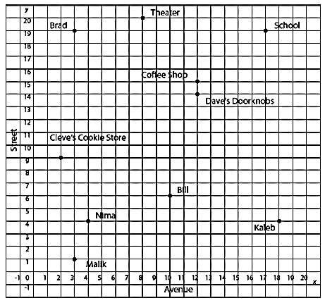
Dave’s Doorknobs. Where is it?

14. The bowling alley is located ¹/₂ of the way
from Malik’s to Kaleb’s. How far will Bill have
to travel to join them?

