Sum and Difference of Cubes.

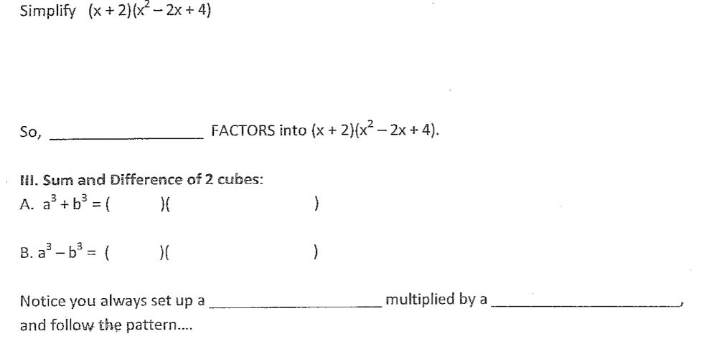

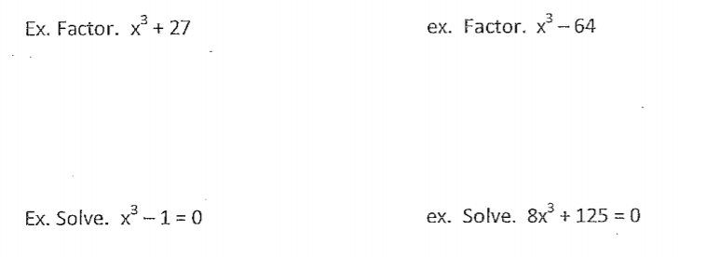

Difference of Squares

Simplify: (x + 5)(x – 5)

So, __________________ Factors into (x + 5)(x – 5)
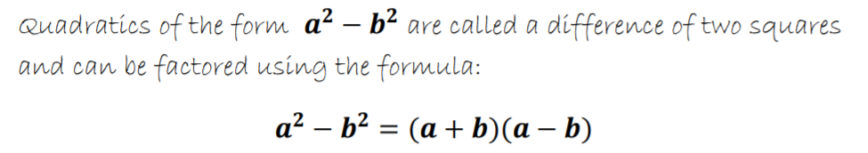

Practice:
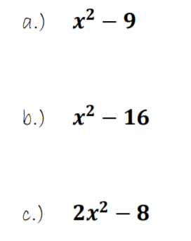

What about this one?
