Average Rate of Change: Linear, Quadratic, and Exponential Functions

_______________ functions have a common ________________ with a ________________ rate of change.

_______________ functions have a common ________________ with a ________________ rate of change.
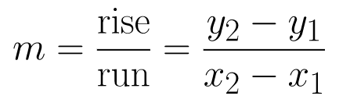
How to solve for Average rate of change:

Example 1: Find the average rate of change over the interval [-1, 2]
a) y = 2x + 3 b) y = x² – 1 c) y = 2^{x} + 1

Which functions has the greatest average rate of change over the interval [-1, 2]?

Example 2: Find the average rate of change from x = 2 to x = 5 for each function.
a) y = 2x + 3 b) y = x² – 1 c) y = 2^{x} + 1

Which function has the greatest average rate of change from 2 to 5?

Conclusion: In general, as x→ ∞, which function eventually grows at the fastest rate?

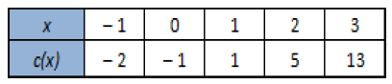
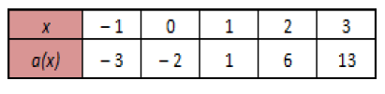
Example 3: Find the average rate of change over the interval [-1, 2] for each continuous function displayed by the tables below.
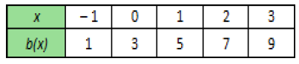
a) b) c)

Which function has the greatest average rate of change?

Example 4: Based on any interval of x in the table provided, which function will always have the greatest average rate of change?
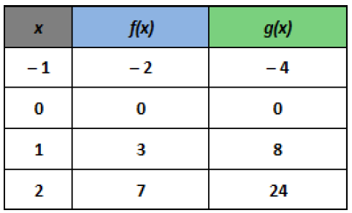

Example 5: Determine the average rate of change for each graph over the interval [1, 3].
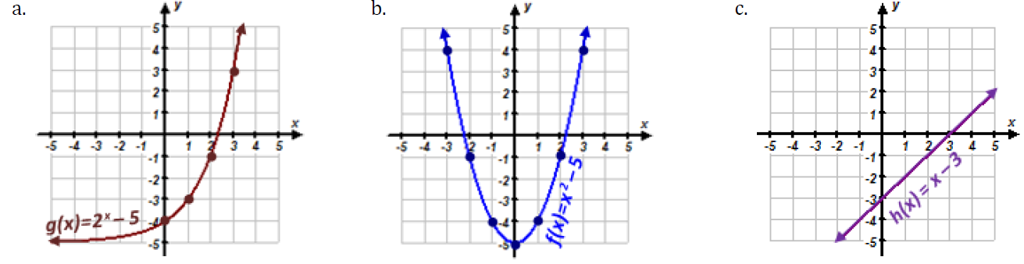

_____________________ _____________________ _____________________

Can you determine which interval for x would produce the same average rate of change for all three functions?

