Name: ________________________________________________ Date: _______________________
Mixed Review (wkst 11.11)

The table below shows data about 108 pizzas sold in a pizzeria. Each pizza was sold with one topping.

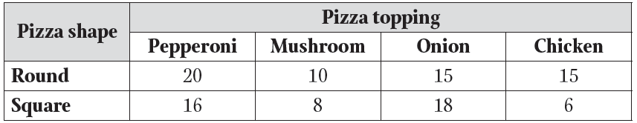

Find each of the following probabilities if a one topping pizza is picked at random.
- Find P(Square) 48/108
- Find P(Mushroom) 18/108
- Find P(Round ∪ Mushroom) 68/108 (Remember U means “or”)
- Find P(Square ∩ Chicken) 6/108 (remember means “and”)
- Find P(Round ∩ Onion)’ 93/108 (remember ‘ means “not”)

You have a cooler full of drinks, sandwiches and chips. There are 3 different kinds of drinks, 4 different types of sandwiches, and 5 different types of chips.

6. How many possible combinations are there for picking one of each item? 60

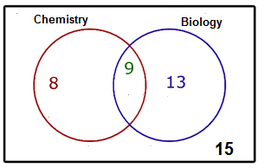
- Find P(Biology) 22/35
- Find P(Chemistry ∩ Biology) 9/45
- Find P(Chemistry ∪ Biology) 30/45
- Find P(Chemistry)’ 28/35

A person rolls two dice, one after the other. Find the probability of the following events.
+ | 1 | 2 | 3 | 4 | 5 | 6
1 | 2 | 3 | 4 | 5 | 6 | 7
2 | 3 | 4 | 5 | 6 | 7 | 8
3 | 4 | 5 | 6 | 7 | 8 | 9
4 | 5 | 6 | 7 | 8 | 9 | 10
5 | 6 | 7 | 8 | 9 | 10 | 11
6 | 7 | 8 | 9 | 10 | 11 | 12

- P(even sum) or P(less than 4) 20/36

- P(even sum) or P(sum of 11) 20/36

- P(doubles) or P(odd sum) 24/36

The following table shows the concession stand sales at a Friday night football game.
- If a random person is selected, what is the probability that they ordered a hot dog? 158/400
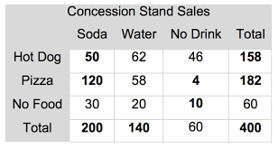

- If a random person is selected, what is the probability that they got pizza or soda? 262/400

