Name: ________________________________________________ Date: _______________________
Mixed Review (wkst 11.11)

The table below shows data about 108 pizzas sold in a pizzeria. Each pizza was sold with one topping.

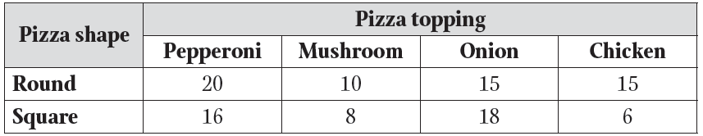

Find each of the following probabilities if a one topping pizza is picked at random.
- Find P(Square)
- Find P(Mushroom)
- Find P(Round ∪ Mushroom)
- Find P(Square ∩ Chicken)
- Find P(Round ∩ Onion)’

You have a cooler full of drinks, sandwiches and chips. There are 3 different kinds of drinks, 4 different types of sandwiches, and 5 different types of chips.

6. How many possible combinations are there for picking one of each item?

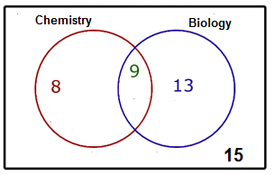
- Find P(Biology)
- Find P(Chemistry ∩ Biology)
- Find P(Chemistry ∪ Biology)
- Find P(Chemistry)’

A person rolls two dice, one after the other. Find the probability of the following events.
+ | 1 | 2 | 3 | 4 | 5 | 6
1 | 2 | 3 | 4 | 5 | 6 | 7
2 | 3 | 4 | 5 | 6 | 7 | 8
3 | 4 | 5 | 6 | 7 | 8 | 9
4 | 5 | 6 | 7 | 8 | 9 | 10
5 | 6 | 7 | 8 | 9 | 10 | 11
6 | 7 | 8 | 9 | 10 | 11 | 12

- P(even sum) or P(less than 4)

- P(even sum) or P(sum of 11)

- P(doubles) or P(odd sum)

The following table shows the concession stand sales at a Friday night football game.
- If a random person is selected, what is the probability that they ordered a hot dog?
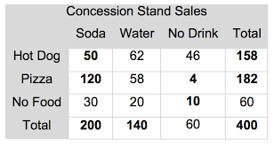

- If a random person is selected, what is the probability that they got pizza or soda?

