To Create Quizizz Account
- Access the blog and click on your class: Algebra OR H. Geometry
- Click your class period in order to access quiz
- Create account
  - Input email, and click Accept Invitation
  - If there are follow up questions, go ahead and answer them
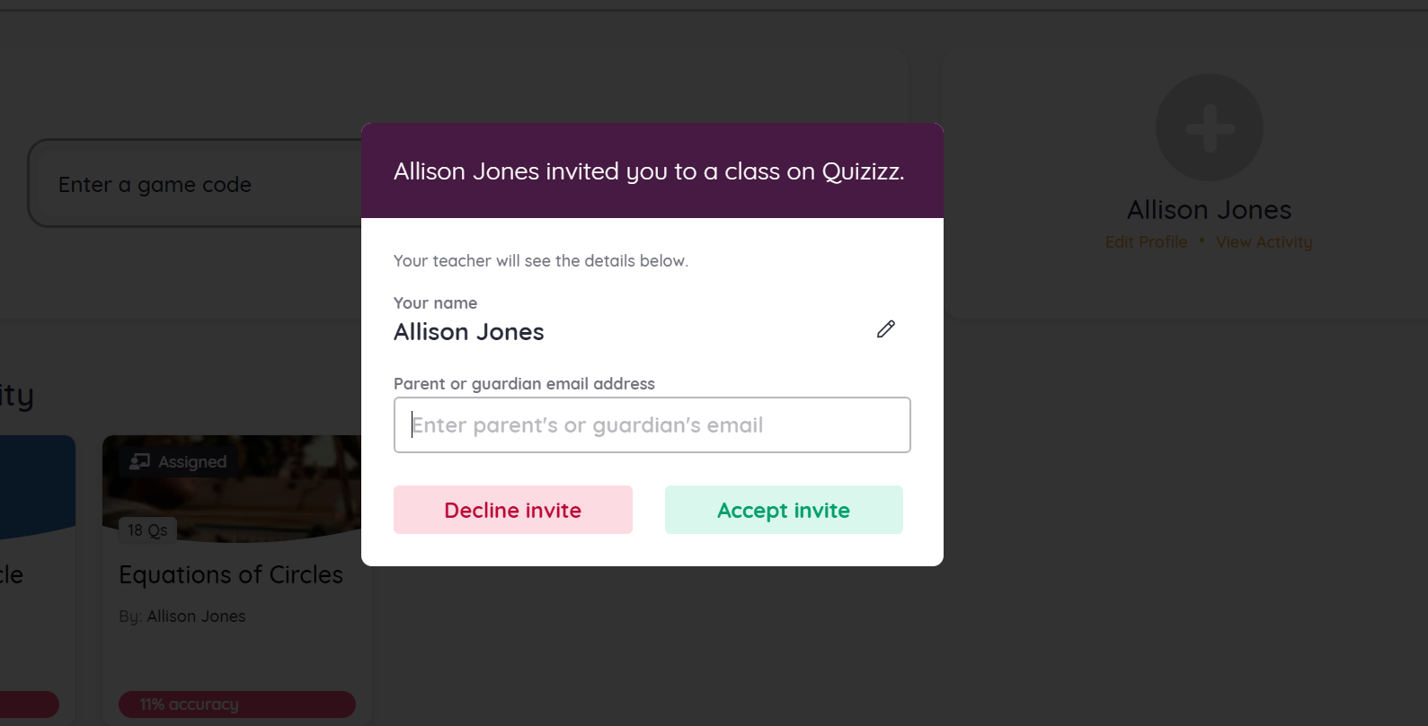

- After hitting “accept invitation,” refresh your browser (the screen does not go away on its own)
  - At this point you are logged in

- Locate “game code” at the top of the page
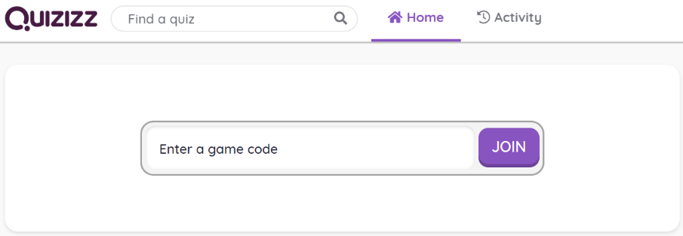

6. Enter game code associated with your class (found by class link on blog) and click join.
7. Press “start” and complete assessment.

