Probability Test Review Name _____________________________

Period _____ Date ________________

1. Out of 140 HS teachers, 50 go to the gym regularly, and 17 are Math teachers.
5 of the Math teachers go to the gym regularly. How many HS teachers teach Math or go to the gym regularly? (Hint: A Venn diagram might help by drawing it below)

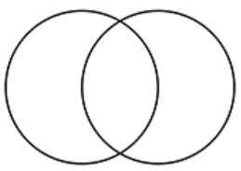

d. What is the probability of teachers that teach Math but do not go to the gym?

e. What is the probability of teachers who neither teach Math nor go to the gym?

2. On this season of Make Me a Superstar, there are 16 contestants. 7 contestants are female, 5 contestants are blond, and 2 of the female contestants are blond.
male
blond
- Complete the Venn Diagram shown by writing
how many contestants are in each group.

b. How many female contestants are there?

c. P(blond females)?

d. How many contestants are neither female nor blond?

e. P(female blond’)?

FOR THIS ENTIRE SECTION, USE THE FOLLOWING INFORMATION:
You have a box with ten blue cards numbered 1 through 10, ten red cards numbered 1 through 10, ten yellow cards numbered 1 through 10, and ten green cards numbered 1 through 10.

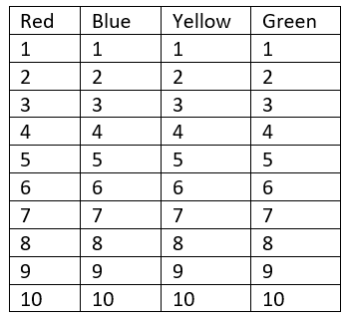
3. You randomly pick one card from the box

a. Event A: Get blue. Event B: Get a number greater than 6.
Are events A and B mutually exclusive? Explain.

P(A and B) = P(A or B) =

b. C: Get a yellow. D: Get red.
Are events C and D mutually exclusive? Explain.

P(C and D) = P(C or D) =

4. Imagine drawing two cards from the box, one after the other.

a. You replace the card between draws.
A: Get a ten on the first draw. B: Get a nine on the second draw.

Are events A and B independent or dependent? Explain.

P(A and B) =

b. You do not replace the card between draws.
C: Get a ten on the first draw. D: Get a nine on the second draw.

Are events C and D independent or dependent? Explain.

P(C and D) =

5. You randomly draw a card. What is the probability…

a. it is red? b. it is less than 3?

c. it is either green or an 8? d. it is green and greater than 8?

e. it is blue or less than 8? f. it is blue’ and it’s less than 8?

Complete the two-way frequency table.
 | Dogs | Cats | Fish | Total
Male students | 6 |  | 4 | 14
Female students |  | 10
Total | 11 |  | 5

6. How many total students took the survey? Is this a joint or marginal frequency?

7. How many female students are in the class? How many male students are in the class? What kind of frequencies are these?

Female: _______________________ Male: _______________________ Type of Frequencies: _______________

8. Who likes dogs more than cats, male students or female students? Are you comparing the joint or marginal frequencies?

9. What is the probability that a student surveyed was a male student who like dogs?

10. Find the probability that a student surveyed was a female.

11. Percentage (cats)?

12. P(female fish)?

13. Out of all the students surveyed, what percent of them are females who like dogs?

14. Given that a female is chosen, what is the probability she preferred cats as pets?

15. What percent of male students preferred dogs for pets?

16. P(male | dogs)?

17. What is the probability that a person chosen is a female that prefers fish?

18. What is the probability that a person chosen is female, given that they prefer fish as a pet?

19. What is the probability that a person chosen prefers fish, given that the person is female?

20. P(dogs | female)?

21. What is the probability that a student surveyed is male?

Probability Review Key

1. a. 30
b. 6

2. a. 62
b. 12
c. 78

3. a. no (explain)
4/40 or 1/10
22/40 or 11/20
b. yes (explain)
0
20/40 or 1/2

4. a. independent (explain)
16/1600 or 1/100
b. dependent (explain)
16/1560 or 2/195

5. a. 10/40 or 1/4
b. 8/40 or 1/5
c. 13/40
or anything that equals 0.325
*If you had a WRONG answer of 14/40, you forgot about the OVERLAP of the “green 8” card!
d. 2/40 or 1/20
e. 7/40
f. 21/40

6. a. Careful! The TOTAL in the male circle should be 7, and the TOTAL in the blond circle should be 5. Start in the intersection (the middle), then fill in the rest.
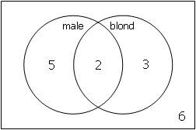
b. non-male: 9
c. blond but not male: 3
d. male but not blond: 5
e. not male and not blond: 6

