Name: __________________________________________ Date: _____________________________

“OR” Rule: Mutually Exclusive vs. Overlapping

Vocabulary:
- Compound Event
  - _________________________________________________________________________
- Mutually Exclusive
  - _________________________________________________________________________
- Overlapping
  - _________________________________________________________________________

Mutually Exclusive

The probability that one or the other of several events will occur
is found by summing the individual probabilities of the events:

- Find the probability that a girl’s favorite department
Macy’s | 0.25
Saks Fifth Ave. | 0.20
Nordstrom | 0.20
JC Penny’s | 0.10
Bloomingdale’s | 0.25

store is Macy’s or Nordstrom.

Find the probability that a girl’s favorite store is not JC Penny’s.

- When rolling two dice, what is probability
+ | 1 | 2 | 3 | 4 | 5 | 6
1
2
3
4
5
6

that your sum will be 4 or 5?

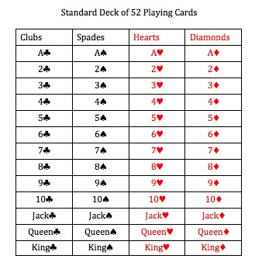
- What is the probability of picking a queen or an ace from a deck of cards?

Overlapping Events

Probability that non-mutually exclusive events
A and B or both will occur expressed as:
P(A or B)
P(A ∪ B) = P(A) + P(B) – P(A ∩ B)

- Find the probability of picking a king or a club in a deck of cards.

- Find the probability of picking a face card or a red card in a deck of cards

- Find the probability of picking a female or a person from Florida out of the committee members.
 | Female | Male
Florida | 8 | 4
Alabama | 6 | 3
Georgia | 7 | 3

- When rolling 2 dice, what is the probability of
+ | 1 | 2 | 3 | 4 | 5 | 6
1
2
3
4
5
6

getting an even sum or a number greater than 10?

