Algebra 1 Name: _______________________________  
Comparing Functions – Transformations Date: ___________________

RECALL: Decide whether the following functions are linear, exponential, quadratic, or neither.

|  |  |
| --- | --- |
| **x** | **y** |
| -3 | 14 |
| -2 | 10 |
| -1 | 6 |
| 0 | 2 |
| 1 | -2 |
| 2 | -6 |
| 3 | -10 |

|  |  |
| --- | --- |
| **x** | **y** |
| -3 | 21 |
| -2 | 12 |
| -1 | 5 |
| 0 | 0 |
| 1 | -3 |
| 2 | -4 |
| 3 | -3 |

|  |  |
| --- | --- |
| **x** | **y** |
| -3 | 1/9 |
| -2 | 1/3 |
| -1 | 1 |
| 0 | 3 |
| 1 | 9 |
| 2 | 27 |
| 3 | 81 |

1. 2. 3.

Let’s remind ourselves of the following transformations for each function! Are they similar in any way?

1.  2.  3. 

Type of Function: ____________ Type of Function: ____________ Type of Function: ____________

Horizontal Shift: ______________ Horizontal Shift: ______________ Horizontal Shift: ______________

Reflection: none x-axis y-axis Reflection: none x-axis y-axis Reflection: none x-axis y-axis

Vertical Shift: _______________ Vertical Shift: _______________ Vertical Shift: _______________

Dilation: none stretch shrink Dilation: none stretch shrink Dilation: none stretch shrink

Determine if the following functions are linear, exponential, or quadratic, then **describe** all of the transformations that occur.

4.  (1 transformation) 5.  (1 transformation)

6.  (1 transformation) 7.  (2 transformatons)

8.  (2 transformations) 9.  (3 transformations)

10.  (3 transformations) 11.  (4 transformations)

Match the graphs at the bottom of the paper with the given functions.

_______ 1.  _______ 2.  _______ 3. 

_______ 4.  _______ 5.  _______ 6. 

_______ 7.  _______ 8.  _______ 9. 

A. 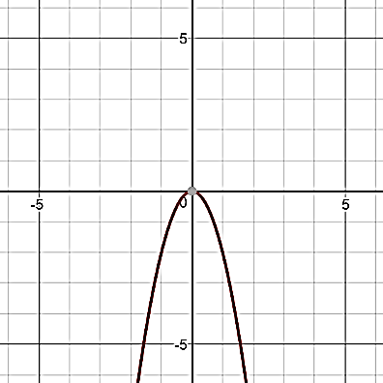 B. 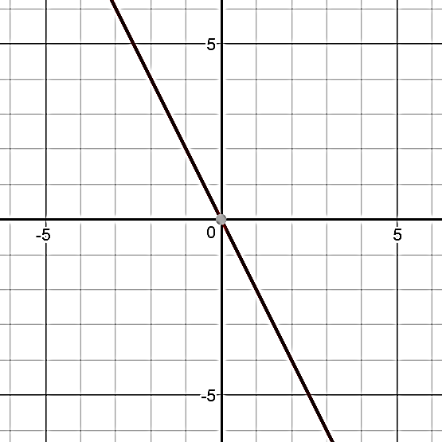 C. 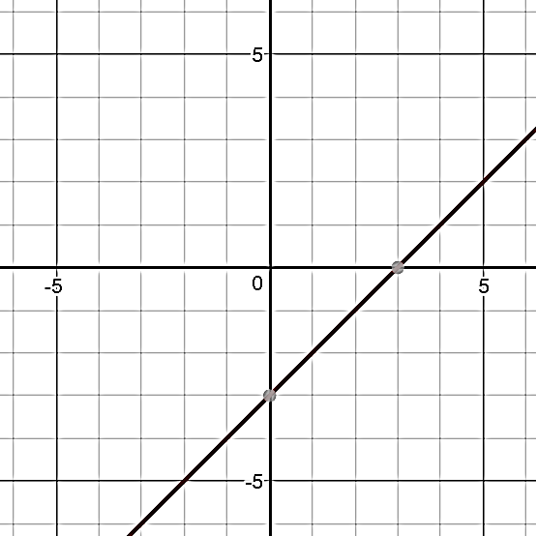

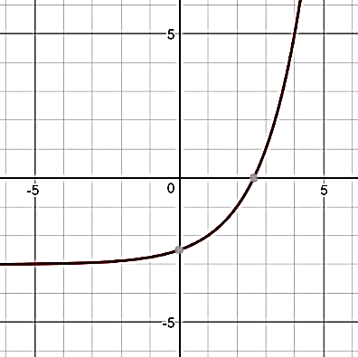D. E. 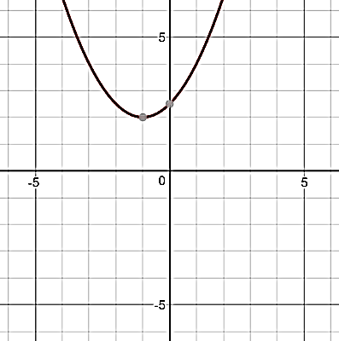 F. 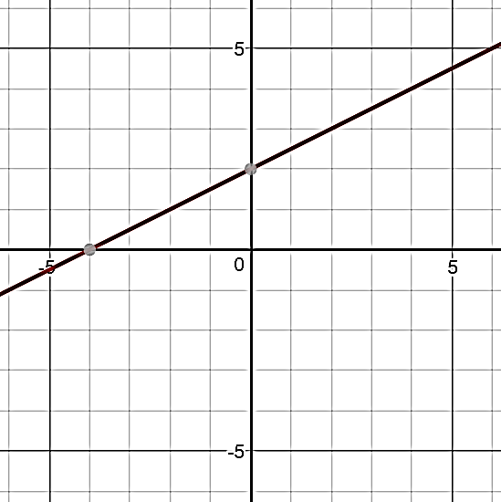

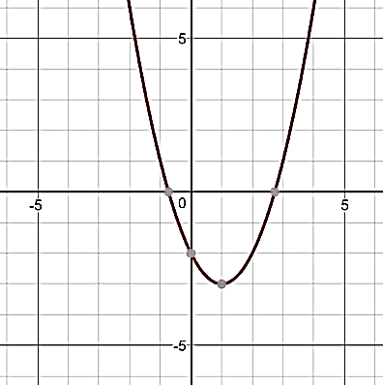

G. 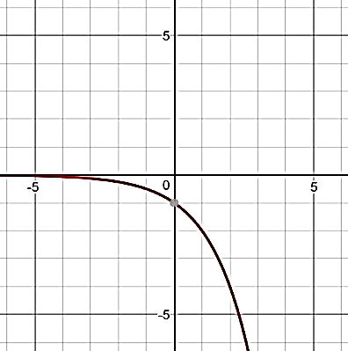 H. 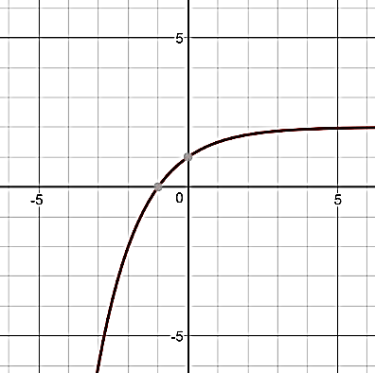 I.