Name Date
Sara has been asked to babysit for a neighbor. She is offered two payment options. With the first plan, she is paid $5.00 per hour. With the second plan, she is paid $0.25 for one hour, $0.50 for two hours, $1.00 for three hours, and so on, as shown in both the graph and the table.
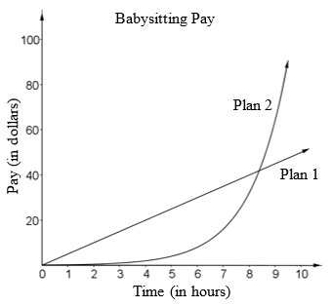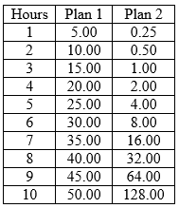
- What type of function is represented by Plan 1?
- What type of function is represented by Plan 2?
- How are the plans alike? Explain.
- How are the plans different? Explain.
- Sara asks you which plan she should choose if she was going to babysit for four hours. What would you tell her? Justify your answer.
- When should Sara choose Plan 2? Why?

