Day 1

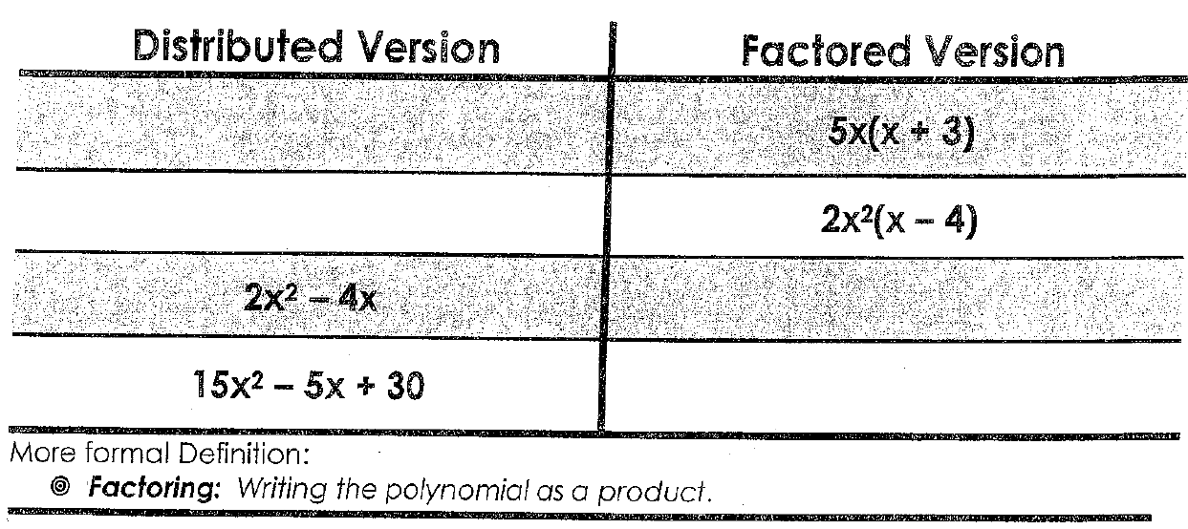
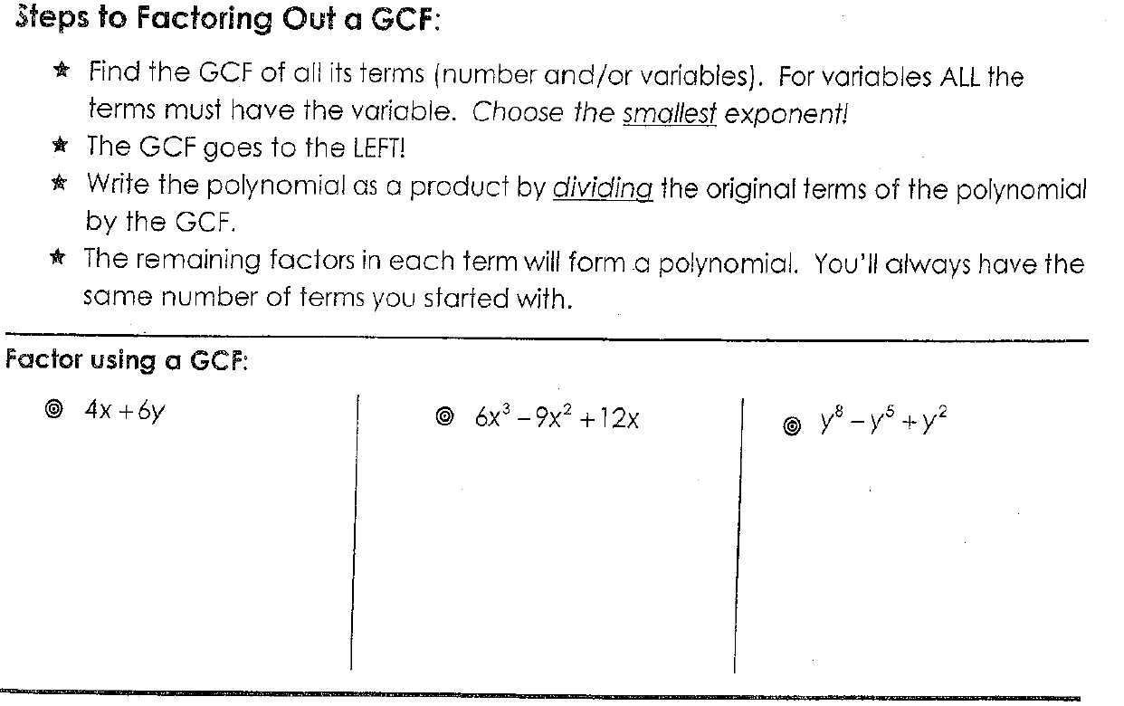

Factor by Grouping
- Take out GCF (if possible)
- Group first two terms, group second two terms
- Take out the GCF for each binomial
- Factor out the common binomial
EXAMPLES:

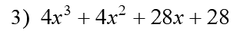

Homework Practice:
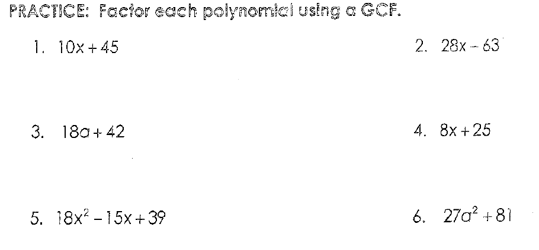

7. 2(x+3)-y(x+3) 8. 3y(x-2) – 4(x-2)

Factor each completely by Grouping.

Day 2: Extra Practice
