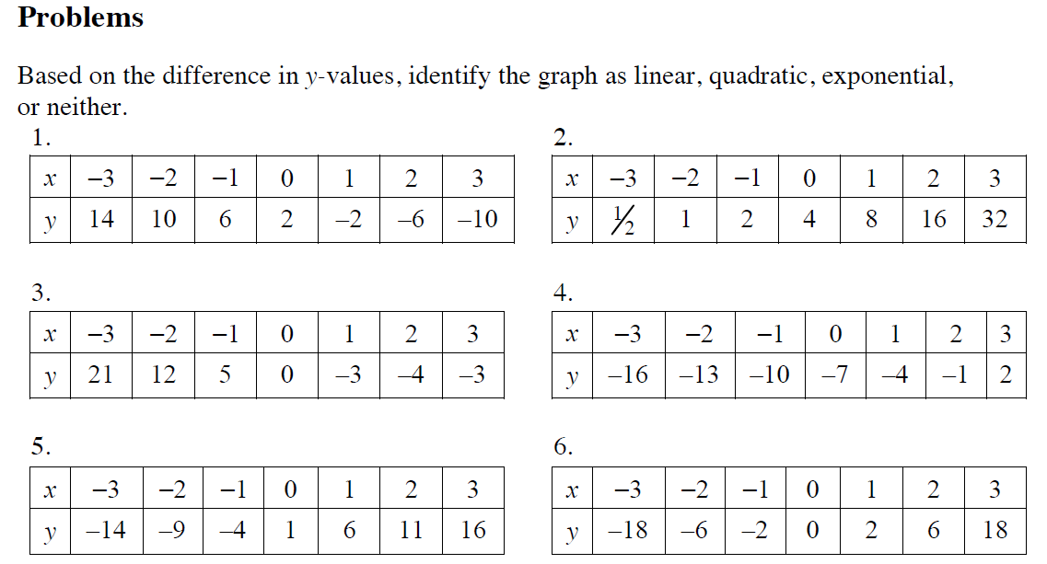
7.
8.
9.
10.

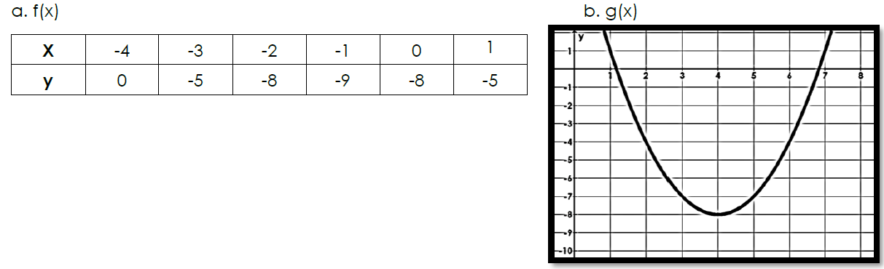
III. Consider the following Scenarios.

11. which quadratic function has the smaller
minimum value? Explain.

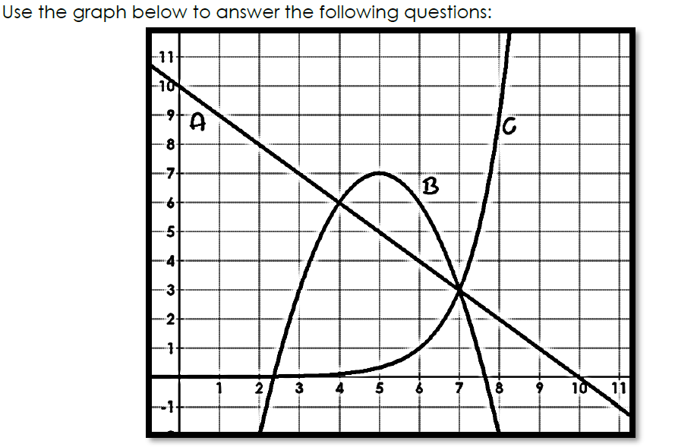

12.

13. Which function has the largest ROC from [3, 5]?

14. Which function has the largest ROC from [7, 8]?

Answer Key
- Linear
- Exponential
- Quadratic
- Linear
- Linear
- Quadratic
- Quadratic Function
  - Stretch by factor of 3, Right 1, down 6
- Exponential Function
  - Reflect over x-axis, stretch by factor of 5, left 4
- Linear Function
  - Up 6
- Vertex goes from (0, 2) to (0, -3). There will be a vertical shift down 5 units.
- In order to find the smallest minimum value, you have to find the vertex.

The vertex of f(x) =(-1, -9) and the vertex of g(x) = (4, -8)

We interpret minimum and maximum values by the y-values of the vertex. In this case f(x) has a smaller y value, therefore it has a smaller minimum value. In a graph, you would see that the vertex for f(x) is lower than the vertex of g(x).

- B, A, C
- B Quadratic
- C Exponential: Exponential will always result in the greatest rate of change over time.

