Determine whether each sequences is an arithmetic sequence.
1. $0, 2, 5, 9, 14, ...$ 2. $37, 34, 31, 28, …$ 3. $-\frac{1}{3}, -\frac{17}{6},-\frac{16}{3},…$

Find the next three terms of each arithmetic sequence.
4. $10, 13, 16, 19, …$ 5. $-14, -19, -24, …$ 6. $\frac{3}{5},\frac{7}{10},\frac{4}{5}, …$

_____, _____, _____ _____, _____, _____ _____, _____, _____

Determine the explicit formula and find the term indicated.
7. $3, 7, 11, 15, …$ 8. $-5, -7, -9, …$ 9. $\frac{2}{9},\frac{5}{9},\frac{8}{9},…$

____________ ____________ ____________
38th term 71st term 24th term

$⋆$10. An arithmetic sequence has a common difference of $-4$ and its 37th term is $10$. Find the first term.

$⋆$11. How many total terms are there in the following sequence? (challenge)

$7, 10, 13, …, 391, 394$

$⋆$13. Write an equation in terms of $y$ and $x$ to represent the sequence $4, 8, 12, …$
(Hint: Use the arithmetic sequence formula, then replace a_{n} with y and n with x).

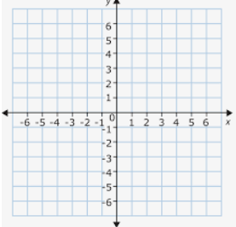
a₁ =________

d = ________

Explicit Formula:_______________

Slope intercept form of equation: _________________

14. Zariah’s 100 meter dash times for her first four races were 14 seconds, 13.4 seconds, 12.8 seconds, and 12.2 seconds.

i) Assuming race times will decrease at the same rate. Write an equation for the arithmetic sequence (Hint: find $a_{1}$ and d first.)

ii) What will the time for her 12th race be?

$⋆$iii) When will she have a time of 11 seconds for the 100 meter dash?

