**Algebra Name _________________________**

**Quiz Review: Linear Inequalities & Systems Date _____________ Period ______**One-variable Inequalities  
 **Solve the inequality and graph the solution.**

1. 3x + 9 < 21 2. –5 11 + 4x 3. 2(k + 4) – 3k14

4. Which of the following are solutions to ? [there can be more than one answer here!]  
A. -3 B. 4 C. 6 D. 10

**Graph each inequality.**

5. x –2 6. x < 5 7. x –1

**Write an inequality and interval for the solution of each graph.**

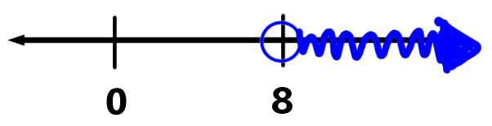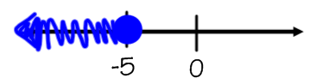

8. 9.

inequality: __________ inequality: __________

interval: ____________ interval: ____________

**Write and solve the inequality that represents each situation.**

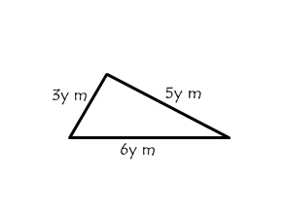

10. Determine the value of y if the perimeter of the triangle is less than 112 meters.

11. Camilla is saving to purchase a new pair of bowling shoes that will cost at least $39. She has already saved $19 and can save an additional $4.50 each week. How many weeks will she need to save?

Two-Variable Inequalities

12. Graph each inequality and determine if the given points are solutions.

1. 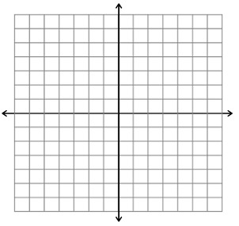 b. 

Is (0, 0) a solution? ___________ Is (1, 1) a solution? ___________

Is (-6, 8) a solution? ___________ Is (3, -2) a solution? __________

1.  d. 

Is (1, -3) a solution? ___________ Is (3, 2) a solution? ___________

Is (2, 1) a solution? ___________ Is (-5, -4) a solution? __________

13. Gina is selling handmade jewelry to earn money for camp. Necklaces sell for $16 and bracelets sell for $4, and she needs to make at least $40 in revenue to cover the cost of camp. Using the graphing grid provided, graph the situation and answer the questions below.

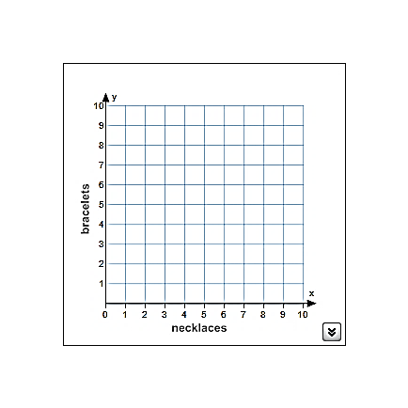

Inequality: ______________________________

Name one possible solution. (____, ____)

Explain your solution in the context of the problem.

Name one possible non-solution (____, ____)

Systems of Inequalities

14. Graph each system of inequalities and give a possible solution.

  
a.  b. 

Possible Solution: ______________ Possible Solution: ______________



c.  d. 

Possible Solution: ______________ Possible Solution: ______________

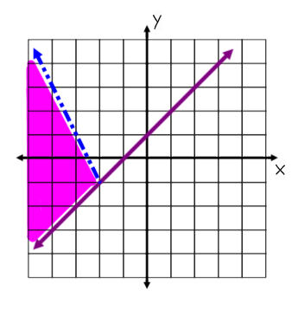15. Use the graph to the right to answer the following questions.

A. Name 3 possible solutions to the system of inequalities.

B. Name 3 points that are NOT solutions to the system of inequalities.

C. Write the two inequalities that are graphed in slope-intercept form.

y _______________________

y _______________________

16. Jordyn has at least $100 in her wallet that consists of $5 and $10 bills. She has at most 16 bills in her wallet. Write a system of inequalities that could be used to describe the scenario. Then graph on the coordinate plane.

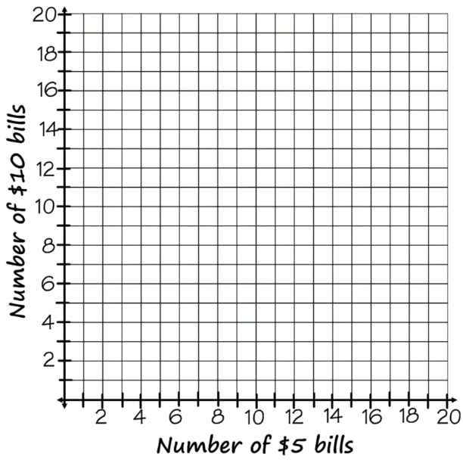

x represents ____________________________

y represents ____________________________

Equation 1: _______________________________

Equation 2: _______________________________

Equations in slope-int form (y=mx+b): ________________________________

________________________________

Name one possible solution: (____, ____)

Write what this solution means in context:

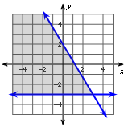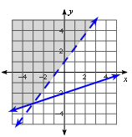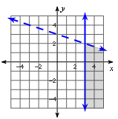_______ 17. 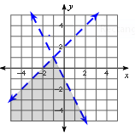Which of these shows the correct graph of this system of inequalities? 

A. B. C. D.