Algebra I Unit 5: Comparing Functions Name: ___________________
Test Review Date: _________Period:____

Determine the first five terms of the sequence.

1. a_{n}= 2n + 38 _____, _____, _____, _____, _____

2. a_{n}= 3(2)^{n-1} _____, _____, _____, _____, _____

3. a₁= -24; an = a_{n-1} + 4 _____, _____, _____, _____, _____

4. a₁= 1/3; a_{n} = a_{n-1}(-3) _____, _____, _____, _____, _____

Write a rule in explicit form for the nth term of each sequence.
5. -36, -38, -40, -42, … __________________________

6. -3, 12, -48, 192, … __________________________

7. a₁₁ = 304; d = 30 __________________________

8. a₅₂ = -228; a₃₄ = -138 __________________________
Write an explicit and recursive rule for the nth term of each sequence. Then find a₈.
9. 2000, 200, 20, 2, … a₈ = _____________________

Explicit Rule: ________________ Recursive Rule: _______________

10. -4, 2, 8, 14, … a₈ = _____________________

Explicit Rule: ________________ Recursive Rule: _______________
State whether the sequence represents a linear function, exponential function, or neither.
11. 1, 3, 6, 10, 15, … __________________________

12. 40, 43, 46, 49, 52, … __________________________

13. -4, 12, -36, 108, -324, … __________________________

14. A first year teacher is paid $38,000. Each year she is paid an additional 5% over the previous year. Create a function that would represent the teacher’s salary based on the number of years.
Initial Value:__________________________
Growth Factor:_______________________
Equation:____________________________

15. A top level professional sports organization offers its athletes two different bonus retirement plans. Read each option, then fill in the tables.

Option 1: They will start an account and add $20,000 per year for each year the player plays successfully for the organization.

Years Played
Retirement Account

Option 2: They will start an account with $20,000 then add 50% to the value of the account for each year the athlete successfully plays for the team.

Years Played
Retirement Account

- Which option would be better for the athlete if he played for the team for 3 years? How much of a difference is there between the two plans?

- Which option would be better for the athlete if he played for the team for 10 years? How much of a difference is there between the two plans?

16. Mr. Rich recently planted a crop of money trees in his garden. Each tree’s growth is represented below.
TREE A | TREE B | TREE C
The first tree was five inches tall when planted. It has grown four inches every month since being planted. | Measurements were taken of the second tree and given below  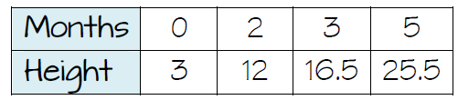 | 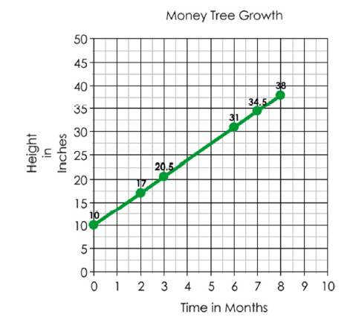

- Which tree is growing the fastest?

- Which tree was the tallest when it was first planted?

- Which Tree is the tallest after six months?

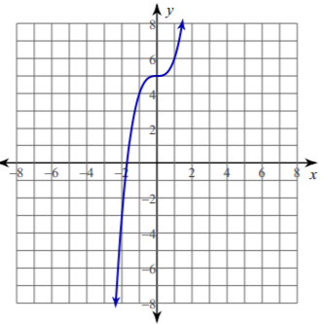
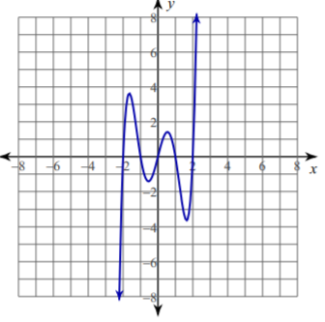
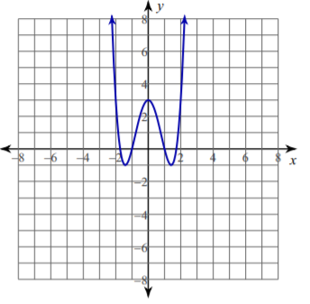
Determine if the functions are even, odd, or neither.
17. 18. 19.

20. h(x) = 4x⁴ – 3x² + 4 21. g(x)= (x +3)(x -2) 22. f(x)= -6x⁵ + 3x³ –x

23. Can you write the equation of a line that can be odd or even?

Explain the transformations of the following functions compared to their respective parent graphs.
24. y = (3/4)^{x} 25. y = 3^{x} 26. y = x²
y = 2(3/4)^{x} – 5 y = (1/2)(3)^{x + 3} + 4 y = -2(x – 1)² + 6

27. Cindy is reading a summer book and made a plan to finish before school starts. She has already read 38 pages and plans to read 52 pages each day before school starts. She has 8 days before the start of school. Will she finish in time? Explain.
Equation:________________________
Conclusion:_________________________________________________________________________
_____________________________________________________________________________________
Determine the following characteristics about the graph of the function above.
Domain:________________________ Range:________________________________
Intercepts:______________________ Increasing/Decreasing:________________
Discrete or continuous. Why?_________________________________________________________

28. Jim is the class president at school and promoting acts of kindness. He started a chain reaction at school in which he gives three people a compliment. It is then their individual duty to give three additional compliments to three new people. Every day the number of compliments is tripling as more students get involved. There is a total of 2100 students at the school. The school’s kindness campaign lasts for 8 days. Will all students be given a compliment at the end of the 8 days? Explain.
Equation:________________________
Conclusion:_________________________________________________________________________
_____________________________________________________________________________________
Determine the following characteristics about the graph of the function above.
Domain:________________________ Range:________________________________
Intercepts:______________________ Increasing/Decreasing:________________
Discrete or continuous. Why?_________________________________________________________
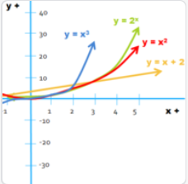
29. a. Which function shows a constant rate of change?

b. Which function shows the greatest rate of change for [2, 4]?

c. Which function will increase the fastest as x→∞?

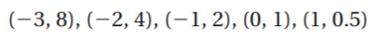
Determine if the function represented by the table of values is linear, quadratic, exponential, or none of these.
30. ____________________________

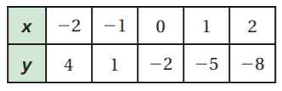
31.

______________________________

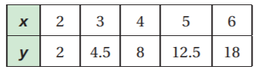
32.

________________________________

