Name: ________________________________________________ Date: _______________________

Mutually Exclusive Practice

Determine if the following events are mutually exclusive or overlapping.

  - The experiment is rolling a die.
The 1st event: the number is greater than 3
The 2nd event: the number is even.

  - The experiment is year in school.
The 1st event: the person is a senior.
The 2nd event: the person is a junior.

  - The experiment is answering multiple choice questions.
The 1st event: the correct answer is chosen
The 2nd event: the answer A is chosen.

  - The experiment is selecting a chocolate bar.
The 1st event: the bar has nuts
The 2nd event: the bar has caramel.

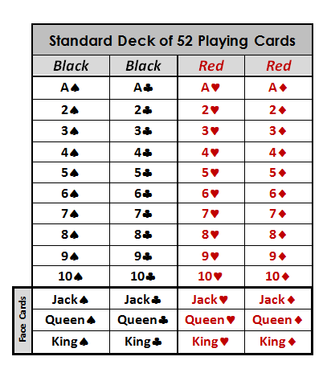
  - One card is randomly drawn from a deck of 52 cards. The card is face down on the table. What is the probability of getting a Jack or a Spade?

Use the general addition rule to compute the probability that if you roll two six-sided dice.
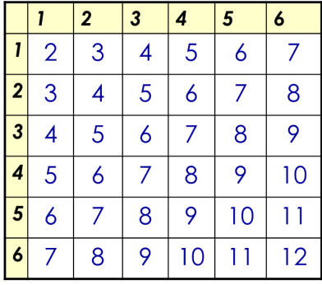

  - you get doubles or a sum of 4

  - you get doubles or a sum of 7

  - you get a 5 on the first die or you get a 5 on the second die.

Use the Venn diagram to answer the following questions.

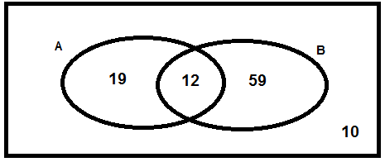
  - P(A)
  - P(B)
  - P(B)’
  - P(A ∪ B)
  - P(A ∩ B)

When you arrive home today, you find 27 cupcakes in a large circular plate.
There are 13 that have icing, 11 have sprinkles, and 4 have both.

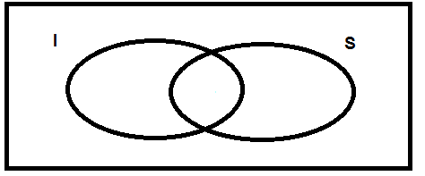

  - P(I)
  - P(S)
  - P(I ∪ S)
  - P(I ∩ S)

Use the data below to find each of the following probabilities.
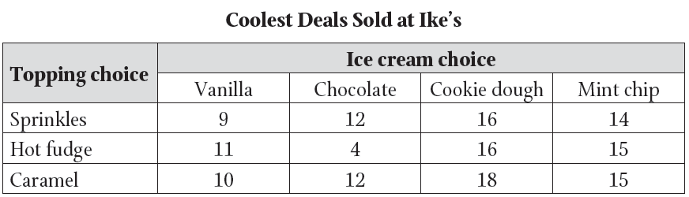

  - P(Chocolate)
  - P(Chocolate)’
  - P(Sprinkles ∩ Cookie Dough)
  - P(Caramel ∪ Vanilla)

