Geometry Name: ______________________

Test Review - Special Right Triangles Date: __________________

I. Special Right Triangles

|  |  |  |  |
| --- | --- | --- | --- |
| 1.  x  y  18  x  y  12  30° | 2. | 3.  x  y  30°  18 | 4.  x  y  45° |
| 5.  x  y  5 | 6.  x  y  15  30°  x  y  30° | 7. | 8.  x  y  60° |
| 9.  x  y  30°  12 | 10.    45°  y  x | 11.    60°  x  y | 12.  48  30°  x  y |
| 13.  14  30°  x  y | 14.  10  30°  x  y | 15. Equilateral Triangle  x | 16.  y  x  12  z  45°  30° |

17. Using the ratio for a 45-45-90 triangle, fill in the table.

**LEG LEG HYPOTENUSE**

|  |  |  |
| --- | --- | --- |
|  |  |  |
|  |  |  |
|  |  |  |
|  |  |  |
|  |  |  |

18. Using the ratio for a 30-60-90 triangle, fill in the table.

**SHORT LEG LONG LEG HYPOTENUSE**

|  |  |  |
| --- | --- | --- |
|  |  |  |
|  |  |  |
|  |  |  |
|  |  |  |
|  |  |  |

**II. Pythagorean Theorem**

Put your answers in simplest **radical** form!

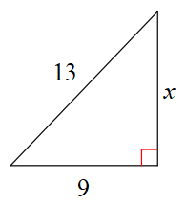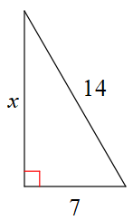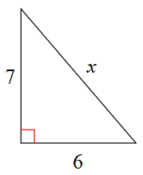

1. 2. 3.

**III. Pythagorean Theorem and Special Right Triangle Word Problems**

1. A ladder is leaning against the side of a house at a 60 degree angle. If the base of the ladder is 7 meters away from the house, how tall is the ladder?

2. An equilateral triangle sides are 20 inches and angles are 60 degrees. What is the length of the altitude?

3. In a 30-60-90 triangle, the longest leg is $6\sqrt{3}$, what is the length of the shortest leg and the hypotenuse?

4. A 15 feet ladder is placed against a wall. What is the distance from the ground straight up to the top of the ladder if it creates a 30 degree angle at the top of the ladder?

5. The diagonal of a square is 24 inches long. What is the length of the sides of the square?

6. An isosceles right triangle has a leg of $4\sqrt{2} cm$. What is the length of the hypotenuse?

7. In a 30-60-90 triangle, the shortest leg is $9\sqrt{6}$, what is the length of the longest leg and the hypotenuse?

8. Find the area of the regular hexagon that has a side length of 24. (Area of triangle = ½bh)

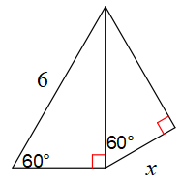

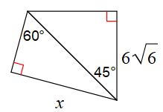**Solve for x.**

9. 10.

**IV. Radical Operations**

1.  2.  3.  4. 

5.  6.  7.  8. 

9.  10.  11.  12. 

13. 14.  15.  16.

17.  18.  19.  20. 

21.  22.  23. 24. 