Geometry Name: _________________________  
Homework – Multiple Transformations

**Using the pre-image point (5, -8), follow the transformations below. Start back at the pre-image for each number. Use your rules!!!**

1. Reflection over the x-axis: ( , ) 2. Translation vector  : ( , )

3. Dilation with a scale factor of ½: ( , ) 4. Rotation of 90 degrees CCW: ( , )   
  
  
5. Translation of  🡪 then Reflection over the y-axis: ( , )

6. Rotation of 180 degrees 🡪 then Dilation of 3: ( , )

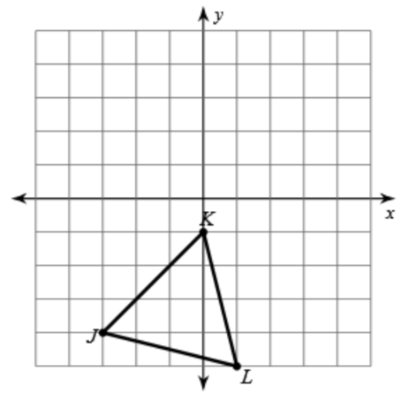**Graph the following compound transformations.**

7. a. Translation 

K’( , ) L’( , ) J’( , )

b. Reflection over the line y = x

K”( , ) L”( , ) J”( , )

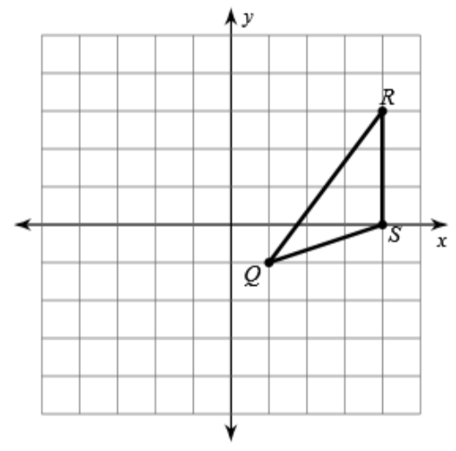

8. a. Rotate 90 degrees CCW

Q’( , ) R’( , ) S’( , )

b. Reflection over the line y = 1

Q”( , ) R”( , ) S”( , )