Algebra 1 – Quiz Review Name: _________________________________ Quadratic Characteristics & Graphing Standard Form Date: _______________
CHARACTERISTICS
Vertex
Domain
Range
Increasing Interval
Decreasing Interval
Zeros
Y-intercept
Maximum
Minimum
Axis of Symmetry
Left End Behavior | As x-∞, y
Right End Behavior | As x∞, y
Fill in the characteristics of the graphs below.
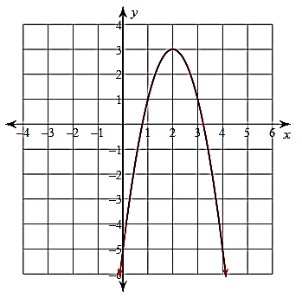
1. y = -2x² + 8x – 5

CHARACTERISTICS
Vertex
Domain
Range
Increasing Interval
Decreasing Interval
Zeros
Y-intercept
Maximum
Minimum
Axis of Symmetry
Left End Behavior | As x-∞, y
Right End Behavior | As x∞, y

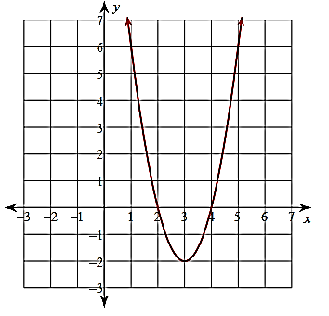
2. y = 2x² – 12x + 16

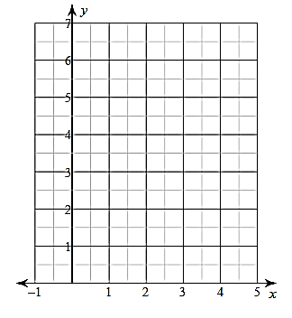
Graph each of the following equations. Answer the given questions.
3. y = x² – 4x + 6 Opens: up or down

Is the vertex a max or a min? _____

Axis of Symmetry: __________

Vertex: __________

y-intercept: __________
x | y

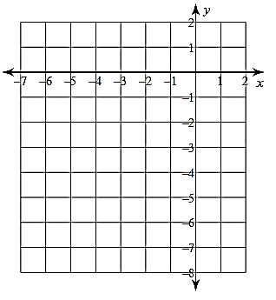
4. y = -2x² – 16x – 31 Opens: up or down

x | y
Is the vertex a max or a min? _____

Axis of Symmetry: __________

Vertex: __________

y-intercept: __________

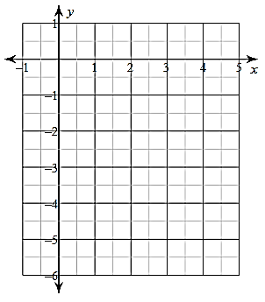
5. y = ½x² – 2x – 2 Opens: up or down
x | y

x | y
Is the vertex a max or a min? _____

Axis of Symmetry: __________

Vertex: __________

y-intercept: __________

